**Term Of Reference**

1. **Functional Requirements**

Membuat sebuah aplikasi **Virtual Event**. Platform ini berbasis web dan apps yang dapat diakses melalui desktop maupun mobile dan android. Beberapa fitur yang ditambahkan pada platform tersebut antara lain :

* 1. Fitur **Nasabah**
* Market Place
* Profil
* Kunjungi Booth
  1. Fitur **Admin**
* Data Master
* Kelola Booth
* Kelola Market Place

1. **System Requirements**

* All OS (Windows / Linux / IOS / Android )
* PHP 7.2.22 – PHP 7.4.18
* Database menggunakan SQL ( MySql / SQL Server / Ms Access)
* Compatible with all latest version Browser
* Build From PHP Framework Laravel 7.2
* Build From Flutter 2.0
* System Reccomended : 60 GB Disk Space
* Unlimited Bandwidth
* Unlimited Website
* 6 GB RAM – 4 Core

1. **Server Requirements**

* Can compatible with OS Redhat / Linux or Window Server
* Amazon Services
* Dedicated server , no one point failure
* Auto Backup Server
* Full Root Access
* Burstable Ram 2x & Ram Dedicated
* Network Link 100Mb/s

1. **Use Case Diagram**

* Use Case Diagram User

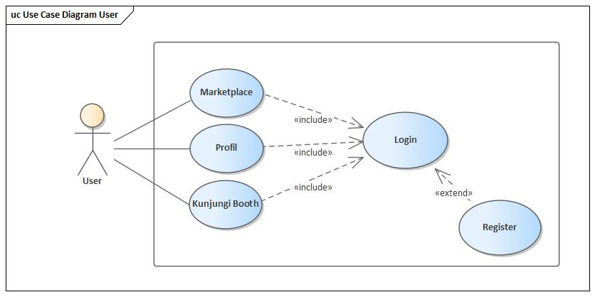

* Use Case Diagram Nasabah

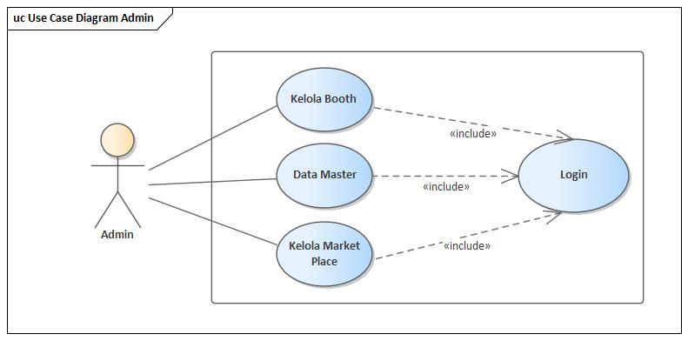

1. **Activity Diagram User**

* 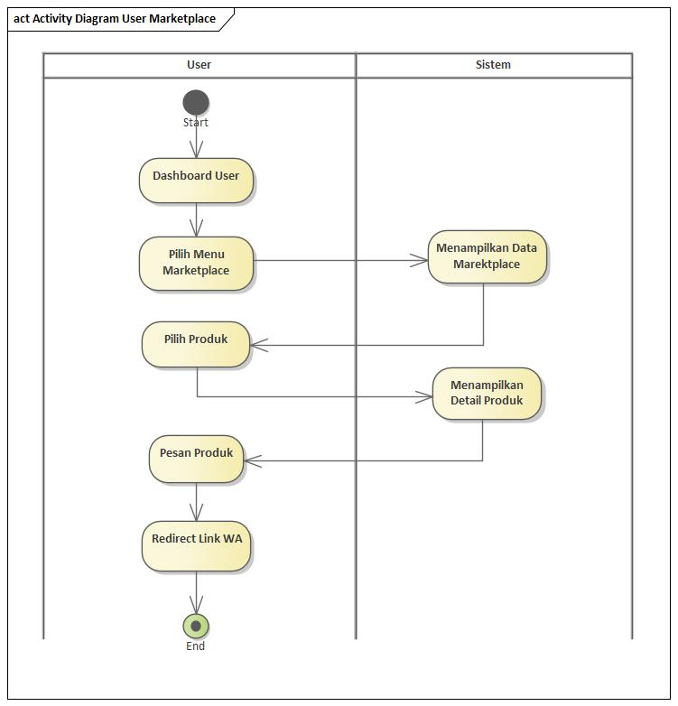**Market Place**
* 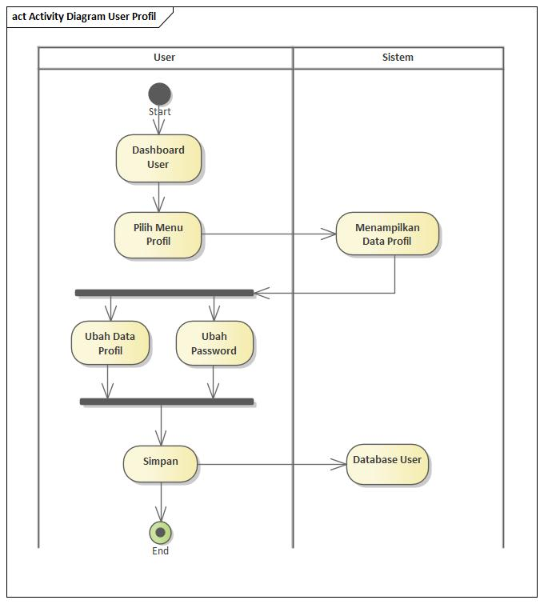**Profil**
* 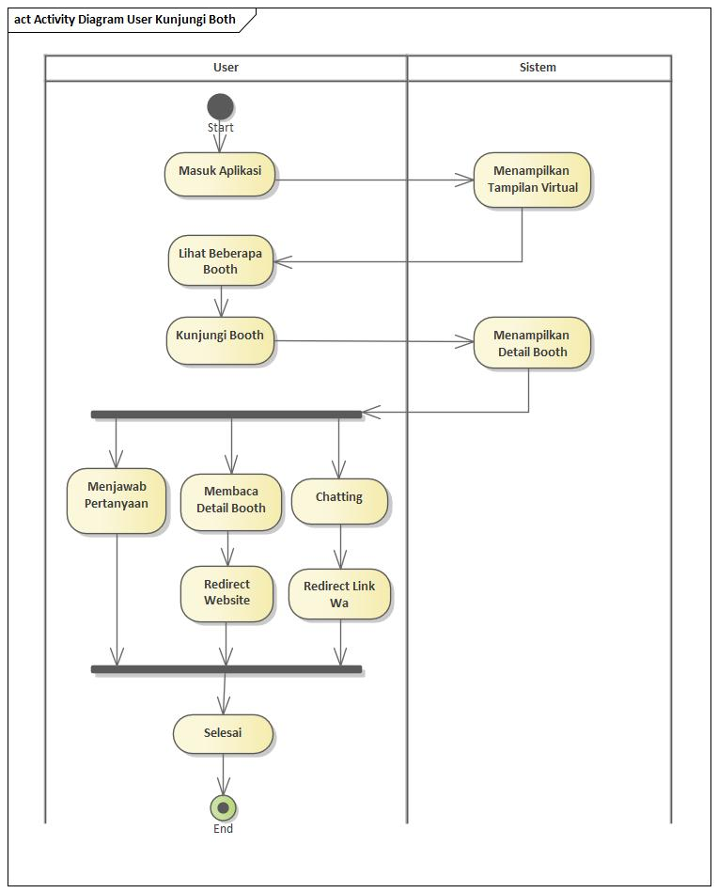**Kunjungi Booth**
* **Login&Register**

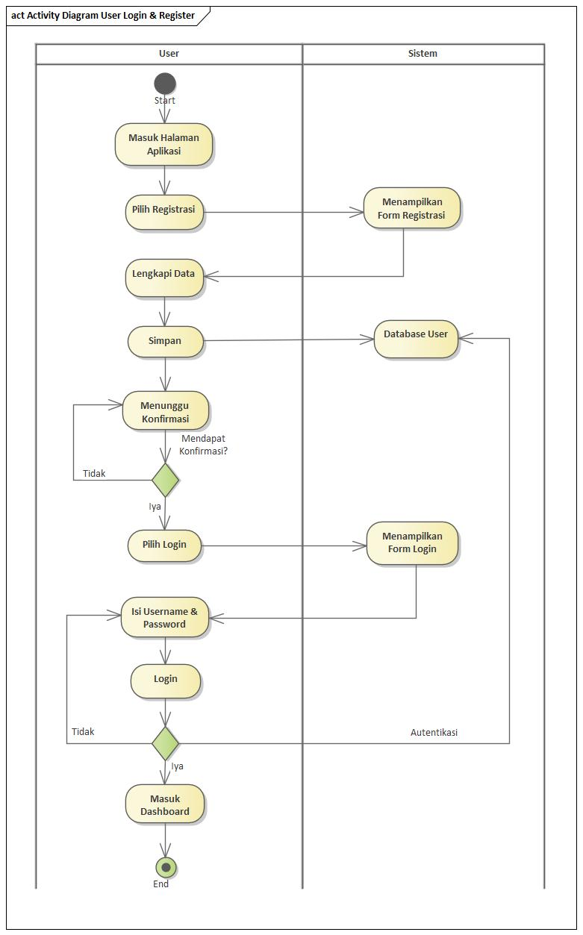

1. **Activity Diagram Admin**

* 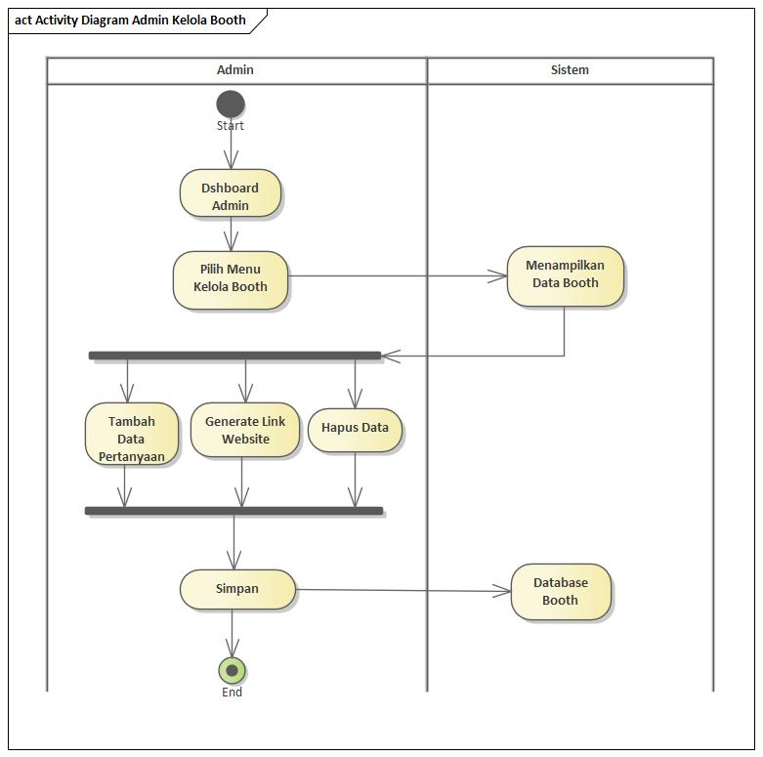**Kelola Booth**
* 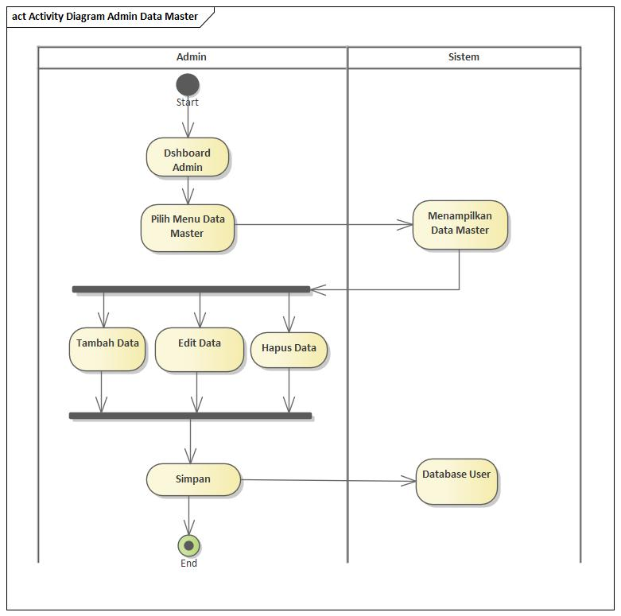**Data Master**
* 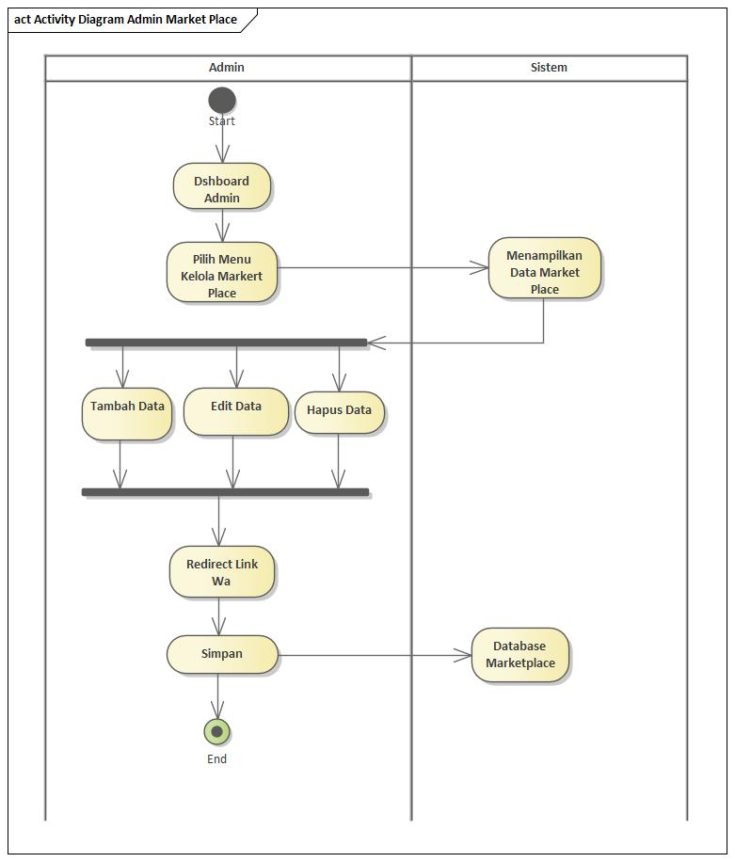**Kelola Marketplace**